Reading instructions for Aidon energy service devices
Aidon 6534 ESD meter is read and can be controlled via remote connection. The electricity can be connected or cut via remote connection. The electricity can be connected or cut also with the Circuit Breaker push button.
In case you wish to cut the electricity from your appartment, please do it primarily with the Circuit Breaker push button. This way, the communication will not be interrupted, and the meter readings can still be read remotely.
During electrical works the electricity must be cut off with the mains switch, and the main fuses must be unplugged.

Energy service device’s indicative LEDs and push buttons
Circuit Breaker LED | Functioning state | Actions
Static green | Electricity is on.
Blinking green | Electricity is off. | Press the Circuit Breaker push button.
Blinking red | Electricity is turned off. User action is blocked. | Contact your energy provider’s customer service. The device is in this state if there is no electricity contract on the metering point.
The lights are off. No text on the meter display. | The device has no power. | Check that the mains switch is on (position I) and the fuses are intact.
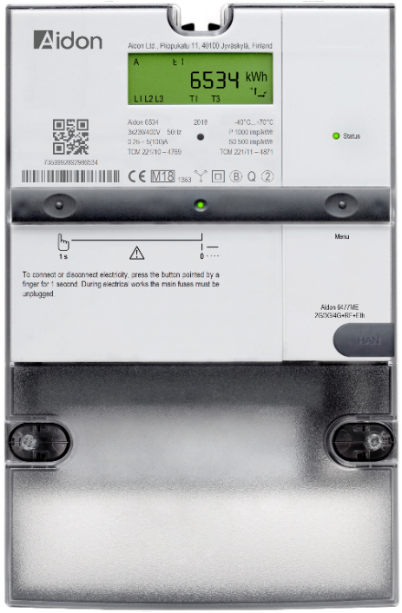
Local HAN port
Circuit Breaker LED.
Energy pulse LED.
Meter display shows the measuring data.
Indicative LED for communication status.
Display push button.
Circuit Breaker push button.
A warning triangle displayed on the meter display indicates an error situation.
In this case, please contact your energy provider’s customer service.

How to read your energy consumption?
In normal operation, the device display shows the total electricity consumption. By pressing the display push button, you can view the time and the date.
Normal display | With display push button
- Total energy consumption | - Total energy consumption (A + kWh)  - Total energy production (A - kWh)  3. Active power (kW A+)  4. Voltage and current per phase

